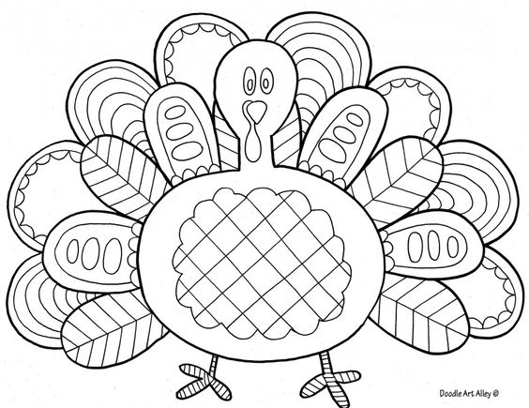 | HBFOL NEWSLETTER  2017 HOLIDAY BOOK SALE  SATURDAY, NOVEMBER 18  9 A.M. TO 12 NOON  1309 BARD STREET, HERMOSA BEACH  1/2 BLOCK WEST OF THE LIBRARY

MOVING RIGHT ALONG . . .
On July 25, 2017, the Hermosa Beach City Council approved the closure of Bard Street south of Pier
Avenue in order to provide protected parking for public safety vehicles (fire trucks, ambulances, police
cars and motorcycles) and the employees who operate them. The city eventually plans to erect gates
at two intersections to the west and south of City Hall and the Police Department: at Bard and Pier
Avenue, and at Bard and 11th Place, and the general public––including Bard Street Book Store
volunteers and customers–– will no longer be allowed entrance. The Book Store will be relocated to a
trailer in front of the city-owned storage facility on the south side of 11th Place, near the intersection with
Valley Drive. .
. . . BUT NOT FOR AWHILE
This project is still in its infancy. There is no date as yet for the projected move; the City is in the process of
soliciting bids for our new quarters. So PLEASE KEEP COMING TO THE BARD STREET BOOK STORE!
Our hours are still 9 a.m. to noon Monday and the third Saturday of every month. The NO RIGHT
TURN/DO NOT ENTER signs posted at the corner of Bard Street and Pier Avenue and on 11th Place at the
exit from the City Hall parking lot do not yet apply to pedestrians or to vehicles bringing boxes of book donations
during our open hours, and the HBPD has assured us of access until our new location is open. Parking is
available on Pier Avenue and behind City Hall, and if you have a large book donation to drop off, you may still
ignore the signs and drive to the front of the store. The same exception applies to picking up purchases too
heavy to carry to your vehicle. Book donations can also be left at the Hermosa Beach Library. For updates, you
can check our website: hbfol.org.
PLEASE KEEP DONATING books in good condition (i.e. gently read). All gifts are tax-deductible, so ask for a
donation slip from one of our volunteers. Our inventory includes hardback and paperback fiction, biographies,
literary classics, books on history, travel, and other popular subjects which we sell for astonishingly low prices.
Most paperbacks are 50¢, most hard covers $1. We also sell CDs, DVDs, and audiobooks at bargain rates.
Books in the children s section are half-price: 10¢ for paperbacks, 25¢ for hardcover. Teachers with i.d.
receive an additional 10% discount.
For help with picking up large book donations, contact us:
Leave a message at the library: 310-379-8475
Leave a message with bookstore volunteer Sue DeLaCamp: 310-379-4127
Contact us by email: Folhb16@gmail.com or C.Gazin@verizon.net
AND REMEMBER TO INCLUDE US IN YOUR END-OF-YEAR GIFT LIST. Use the coupon on the bottom of the page,
return it by mail or in person at the library or at our book store.
Donations can also be made online using the "donate" button.
FOR MORE SALE INFORMATION
Check out our web page: hbfol.org. Or call the Hermosa Beach Library: 310-379-8475.
REMAINING SATURDAY SALE DATES FOR 2017: November 18, December 16
MONDAY BOOK STORE HOURS:
9:00 - 12:00 A.M. (CLOSED ON ALL MONDAY HOLIDAYS).
YOUR GIFTS KEEP ON GIVING
Hermosa Beach CLM (County Library Manager) Katie Sullivan reports on some recent HBFOL
sponsored events and acquisitions:
Some great programs that we ran so far this year due to Friends contributions were our Star Wars
Reads day, which included Jedi Training, Lightsaber construction, storm-trooper bowling, and a
droid scavenger hunt. Another popular program was Puppet Play, during which children created
their own home-made puppets with supplies provided by the Friends and put on puppet shows for
parents and friends. An adult program sponsored by the Friends was a rock painting day: grownups
were invited to paint decorative and inspirational rocks with all supplies provided by the Friends.
A major HBFOL contribution, around $3,000 this year, is periodicals subscriptions. Sixty-six percent
of our periodical budget comes from the Friends. We have also spent several hundred dollars
to supplement our collection, including new children's books and an update of our travel book collection
for patrons who are actually going on trips or who just enjoy reading books and traveling
via their imagination. Thank you for continuing to support our organization, its events, and its volunteers.
2018 ELECTION OF OFFICERS
The following slate will be voted on at the meeting on November 16:
President: Howard Seeb
Vice-President: Dorothy Yost
Secretary: Pat Roberts
Treasurer: George Ceman
THE NEXT HERMOSA BEACH FRIENDS OF THE LIBRARY MEETING WILL BE HELD ON WEDNESDAY,
NOVEMBER 15, AT 2:30 P.M. IN ROOM 4 OF THE COMMUNITY CENTER. ADVANCE NOTICE WILL BE
POSTED ON THE BULLETIN BOARD INSIDE THE LIBRARY. ALL HBFOL MEMBERS ARE WELCOME.
---------------------------------------------------------------------------------------------------------------------------------------------------
PLEASE RENEW YOUR HBFOL MEMBERSHIP FOR 2018: YOUR DUES ARE TAX-DEDUCTIBLE AND
WILL HELP TO PAY FOR PRINTING & MAILING OUR NEWSLETTER. DUES RECEIVED THROUGH
DECEMBER 31, 2016, WILL EXTEND YOUR MEMBERSHIP THROUGH DECEMBER OF 2017.
(Check the mailing label for your current membership status.)
FRIEND: $10, FAMILY: $25, PATRON: $50, LIFETIME: $500
Deliver this form with your check to the library, or mail to HBFOL, P.O. Box 515, Hermosa Beach CA 90254.
NAME_________________________ADDRESS____________________________PHONE______________
E-mail__________________________________________________OK to send newsletter via e-mail?_______________

